**Steps:**

1. **Prepare a CSV or Excel File**:
   * Create a CSV or excel file with the required fields **ID, Work Item Type, Title, Description, Steps, and Expected Results.**

**Sample file**



1. **Navigate to the Test Plan**:
   * In ADO go to **Test Plans**.
   * Open the relevant Test Plan or Test Suite.
2. **Import Test Cases**:

Click on **Import Test Cases** icon and Upload the file

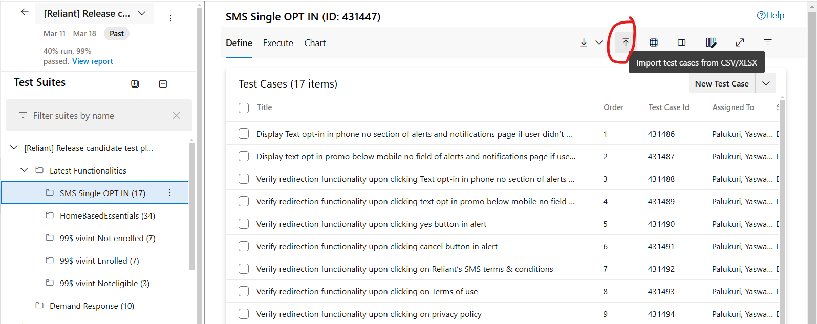

**Export Testcases from ADO**

If user want to download existing testcases then click on download icon it will download the existing testcases in required format so if user want to modify those testcases modify that and reimport that in ado for changes happened

